Khangai Herds 3- Saikhanaa and the Horses

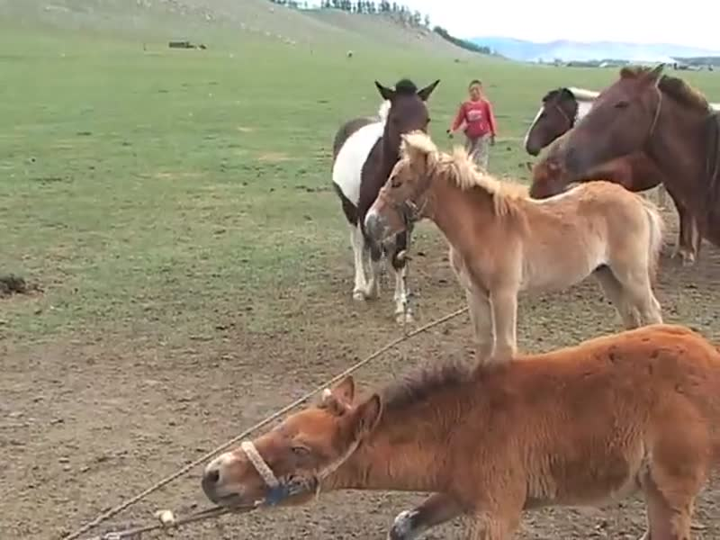

### identifier

e57d9b9c-bd9c-4af8-9c78-a4ae40897ce8

### creator

Fijn, Natasha

### type

Moving Image

### coverage

Mongolia

### description

This is the third installment of Khangai Herds, featuring herders and herd animals in the Khangai Mountains of Mongolia. This segment follows on from 'Saikhanaa and the Calves'. After the cow milking, Saikhanaa assists the men in catching the geldings for the days herding. The men and boys then tether foals to tethering lines for mare milking. Saikhanaa demonstrates his excellent knowledge of the herd animals' genealogy by identifying which young horses are associated with their respective mothers.

### publisher

### source

<https://vimeo.com/13797202>

### rights

<https://creativecommons.org/licenses/by-nc-nd/3.0/>

### subject

Living with Herds

airag

co-domestic

domestication

horses

human-animal

khangai herds

mare milking

milking

mountains

observational film

pastoralisms

visual

### date

2010-08-01

### language

Mongolian

### format

video/mp4

### contributor

### original filename

Khangai Herds 3- Saikhanaa and the Horses.mp4

### remote embed url

https://player.vimeo.com/video/13797202

### relation

### extent

57.6MiB

677.395000